Assignment 8

1. When to use (Rapid Application Development) RAD model. When not to use (Rapid Application Development) RAD model.

When to use RAD Model

- RAD Model is used for the smalls project when product needs to be produced in a short span of time.
- And also this model helps to reduce risks.
- With fewer people productivity is increased in short duration. Here customer is involved.
- All the requirements are gathered before starting development of the project. RAD Model is similar to incremental model and waterfall model. Development should be done in specified time frame. Development starts as soon as requirement is gathered. Initial working prototype is given to the client to get the feedback. Once client gives the feedback, based on the client’s feedback other changes are made.
- Each prototype is delivered to the client with some working functionality and changes made based on the client’s feedback.
- Development moves faster in RAD Model with minimum errors.

When not to use RAD model

- RAD model cannot be used if the total budget for the project is low. Since the cost for modelling, automatic code generation etc is higher.
- RAD model can be used only if there is a strong technical team.
- RAD cannot be used for large or highly complex projects.

2. Define an ER diagram of a software Organization with all the relationship model that was discussed in the classroom
Department
Works
for
Works on
Project
Id
Platform
Name
Client
Id
Controls
Dept Id
1
Employee
Id
Age
DOB
Name
Middle Name
Last Name
Street
Location
Street
N
N

DOB
Phone
Address
Name
Request
for
Dept Name
DOB
Phone
Address
First Name
House Name
Middle Name
Last Name
Location

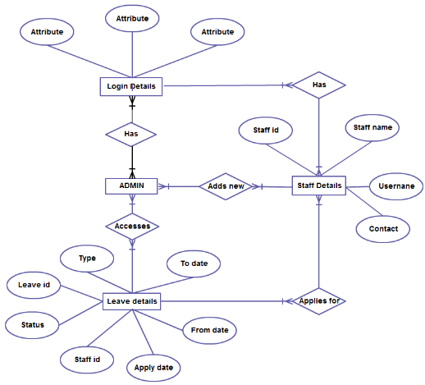
3. Describe the Entity Relationships for the following diagram

Answer:

Login Details, Leave details, Admin , Staff details are the entities.
Staff
- Staff id is the primary key.
- Many staff has differnt login that is many to many relation.
- Many staff applies for many leaves that is many to many relation.
- Staff details has staff name,user name,contacts,staff id.

Admin

- Admins can add new staffs. Many to many relation.
- Leave deatils can be accessed by Admin and is many to many relation.
- Admin has relationship with Login deatils.

Leave details

- Leave deatils has the following attributes type,leave id,status,staff id,apply date,from date,to date.
- Leave id primary key here
- The foreign key staff id used in this entity.

